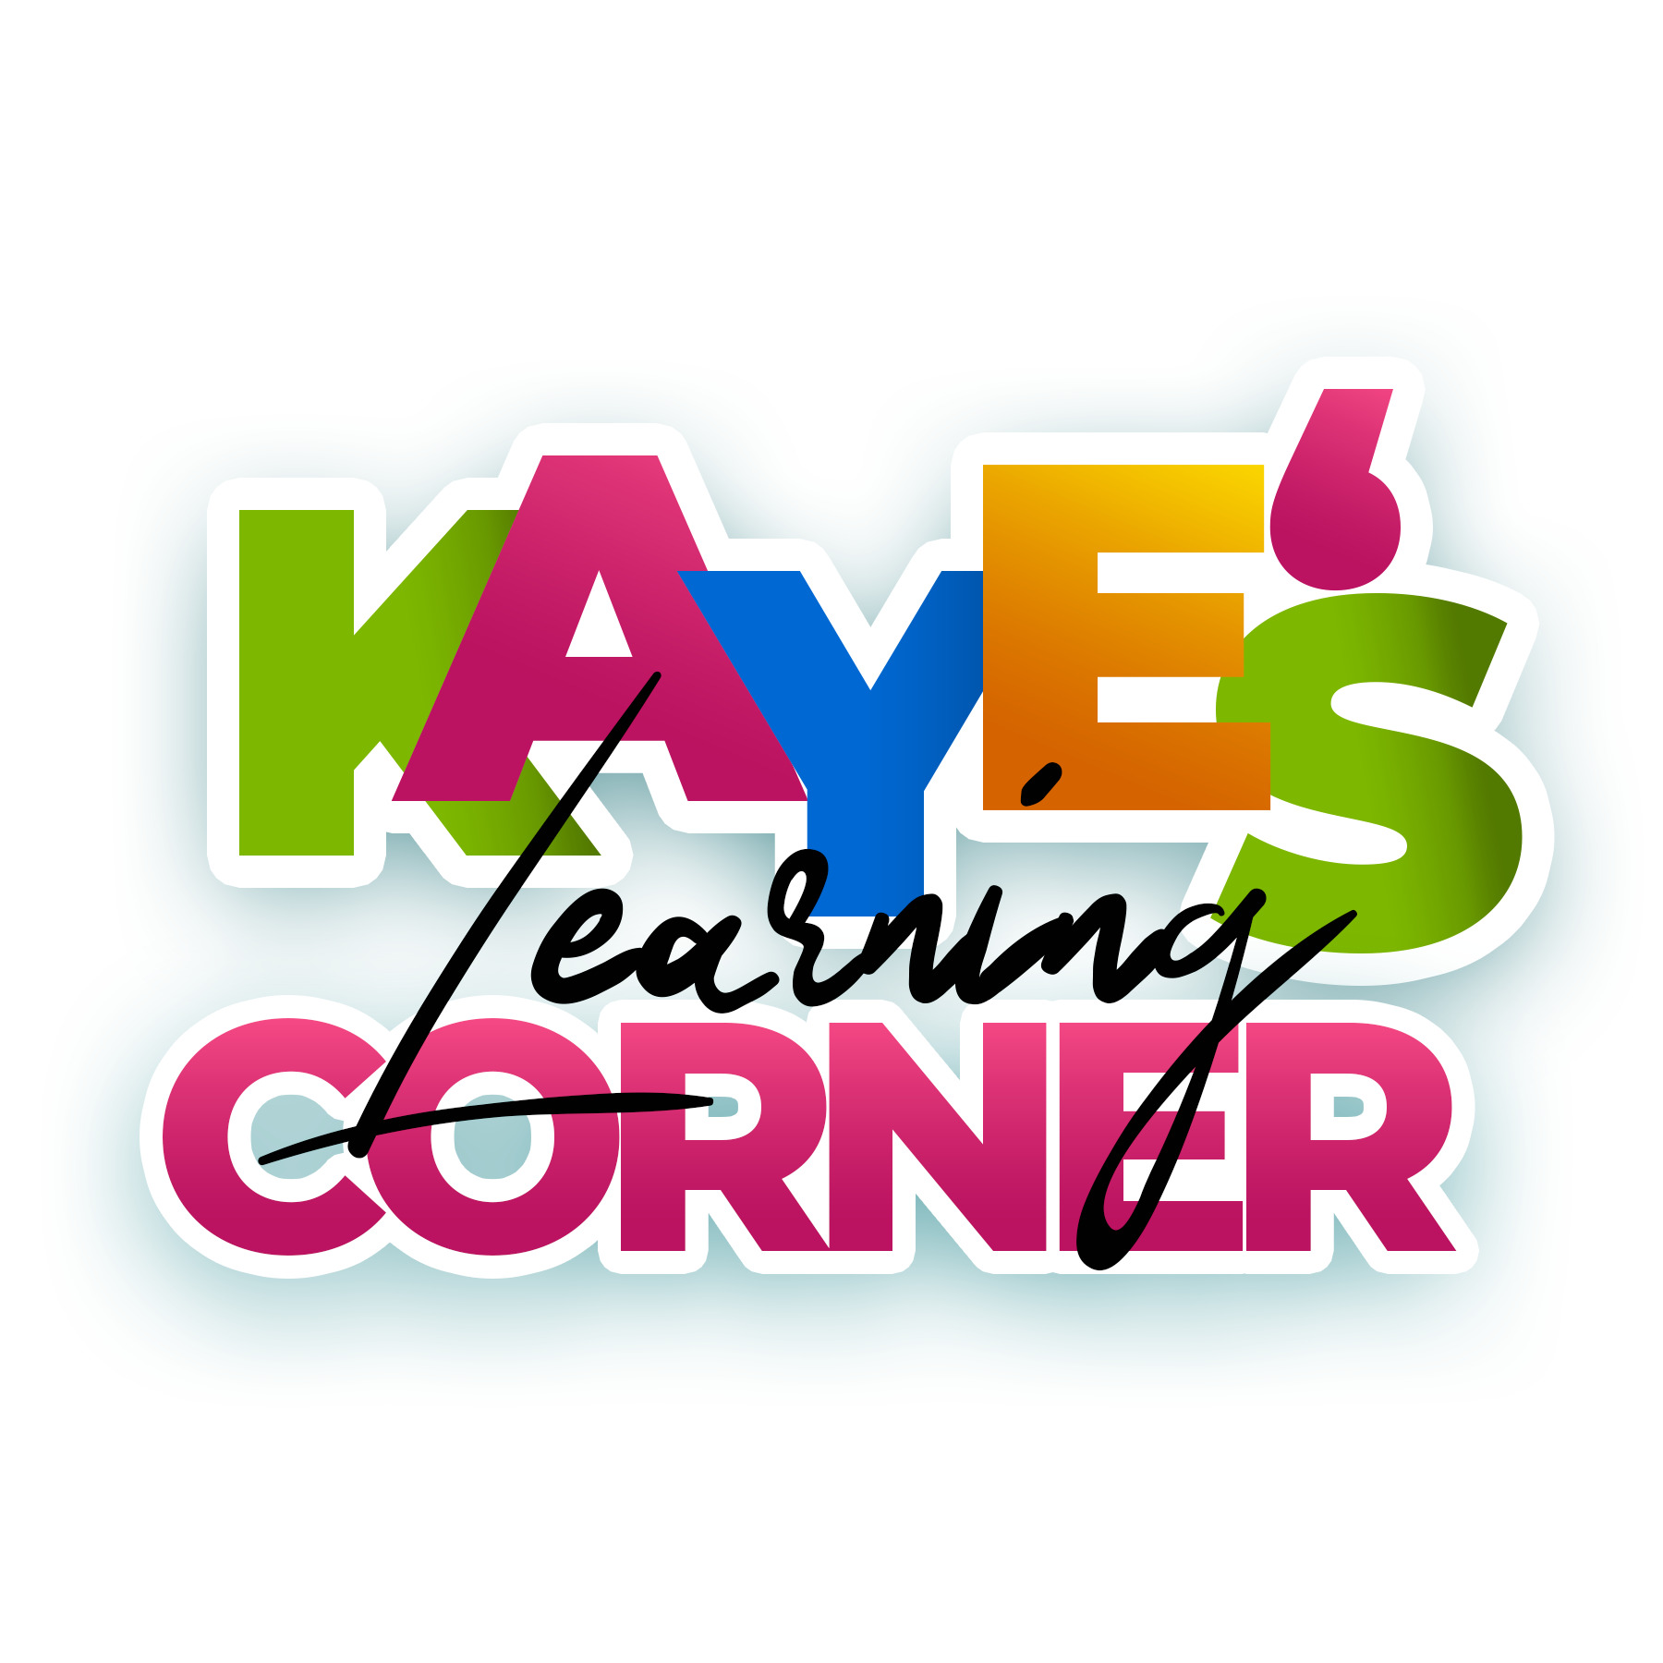

“Education is the passport to the future, for tomorrow belongs to those who prepare for it today.”

Malcolm X

Welcome to the Kaye’s Learning Corner Family

Kaye’s Learning Corner LLC is a learning program that believes EVERY child has the right to a Safe start, A Fair Start, A Moral Start & a Healthy Start.

Kaye believes each child is capable of meeting academic excellence; it is our job to tap into their greatness within.

We appreciate you for choosing us to care for your littles.

We know that choosing childcare is a very important choice to make and it is important for a family to have full confidence in the team that cares for their littles.

We pride ourselves on offering the absolute BEST care we can at very affordable pricing.

- Enrollment & Tuition Fees

- New families who enroll at Kaye’s are required to pay two weeks upfront & a $75.00 enrollment fee per child.

- Littles may not start until ALL fees are paid in full.

- New families do NOT pay again until littles have completed their first two weeks of care.

ENROLLMENT IS NONREFUNDABLE NO EXCEPTIONS!

Additionally, while on breaks tuition is STILL due.

Kaye’s Learning Corner Breaks are as followed.

- Thanksgiving
- Christmas/ New Year
- Spring Break

Kaye’s follows the Kansas City Public Schools Schedule.

We do close for ALL major holidays and inclement weather.

But those closings will always be announced a month in advance.

Your signature below signifies you can & WILL comply with Kaye’s expectations.

- Parent Signature:

________________________________

When Families are ready to depart our Kaye’s Learning Corner Community families MUST give Ms. Crystal a two-week notice.

Families are responsible for that two week of Payment, no exceptions.

Your signature below signifies you can & WILL comply with Kaye’s expectations.

- Parent Signature:

________________________________

When Families first enroll, they are under a 90-day probation, if at any time during this period tuition is paid late it is grounds for termination.

• Infants are $285.00 a week
• Toddlers are $215.00 a week
• Families with (2) Littles are $385.00 a week

Your signature below signifies you can & WILL comply with Kaye’s expectations.

- Parent Signature:

________________________________

The ways Ms. Kaye receives tuition are as followed.

- Cash
- Check
- Cashapp: $KayesLearningCorner
- Apple Pay

Tuition is considered late at 9:00am EVERY Monday.

If tuition is late a mandatory $50.00 late fee will be added.
If not paid littles may not return to Kaye’s until tuition is paid in full with the next weeks tuition as well.

Kaye’s Hours of Operation

Mondays are 7:30 am – 5:30pm
Tuesday – Friday 6:30am -5:30pm

Drop off cut off time is 9:00am

This timeline must be meet for staff to accept.
littles.

When Families first enroll, they are under a 90-day probation period.

if at any time during this period tuition is paid late it is grounds for termination for your contractual agreement.

Scholars will adhere to the following daily schedule:

6:30am Kaye’s is open!

6:30 am -7:30am Early Morning Arrival

7:30am – 8:30am Morning Work & Breakfast

8:30am -9:15am Littles Morning Free Play

9:15am – 9:30am Prep for morning instruction & bathroom breaks

9:30-10:30 Circle Time

10:30 -11:00 Comprehensive Groups/ Spanish / French

11:00 – 11:30 First Lunch / Brain Break

11:30 – 12:00 Second Lunch / Brain Break

12:00 – 12:30 Potty Breaks transition to nap time

12:30-2:30 Nap Time

2:30-3:00 Afternoon Potty break & snack

3:00-3:30 STEM, Music, Art, Swimming & boxing

3:30-4:30 Free Play

4:30 -5:30 Clean Up & transition to school room

5:30- Last call for dismissal

Kaye’s Learning Corner observes ALL HOLIDAYS, no instruction will be given.

Please be advised that tuition is still due on the weeks we are on break.

In the event of inclement weather Parents will be notified of closings via
Bright wheel as your safety is our priority.

If your child(ren) are sick and show any symptoms you will be required to pick them up. Parents must be here to get littles within an hour of communication.

Littles may not return until they are 24 hours free of fever and symptoms with no medical assistance.

Your signature below signifies you can & WILL comply with Kaye’s expectations.

- Parent Signature:

________________________________

Kaye’s is a learning program where we believe our children reach their best potential.

with family support, so we do ask that parents are compliant and engaged with your kiddos learning.

Each parent that is receiving care MUST supply the following:

A Blanket and Pillow for nap time, an extra change of clothes for littles to stay in their cubby.

Diapers, Pull-ups & Wipes that will stay at Kaye’s and last an entire month.

These are due by the 5th of each month.

Please be prepared to download, check, and communicate via Bright wheel.

BRIGHTWHEEL IS OUR MAIN SOURCE OF COMMUNICATION.

Additionally, please understand that parent compliance is a key factor in the everyday
success of Kaye’s Learning Corner, parent’s failure to comply.

Lack of respect of staff, supplying contributions late on a continued basis can result in
your child being dismissed from Kaye’s Learning Corner.

Crystal Turner: Kaye’s CEO

___________________________________

Parent Signature:

_____________________________________

Date of Enrollment:

_________________________________________

Home Address:

Emergency Contact Information

Emergency Contact Name:

__________________________

Emergency Contact Phone Number:

_____________________________

Second Emergency Contact

_____________________________

Second Emergency Contact Phone Number: __________________________________

Kaye’s Learning receives donations from many businesses. Many times, they request to
take photos for their documentation of services provided.

By checking Yes below,

You give Kaye’s Learning permission to use photos, images, video recordings where applicable) of your child(ren)

____ Yes, I consent to Kaye’s Learning Corner and its affiliates to use images/videos.
recordings of my child(ren).

____No, I do not consent to Kaye’s Learning Corner and its affiliates to use.

images/video recordings of my child(ren).

- KAYES CARE IS THE BEST CARE-

